Practice Activity: Create an Orientation presentation in PowerPoint
Before You Begin
✅ Download all attached files.
✅ Save the files in your Office Fund folder before starting.

Purpose
In this assessment, you will use presentation software (PowerPoint) to design concise, well-organized presentations and create engaging, informative slides.
Key skills in this practice include:

- creating a new presentation,
- entering text,
- presentation views,
- presentation themes,
- speaker notes,
- adding and formatting pictures,
- printing a presentation, and
- Header and Footer options.

Step 1: Open and Save Your Document
- Start PowerPoint, notice how it opens in Backstage View.
- Under New > Click More Themes > Single click on Facet
    - If the Facet theme is not visible, use the search to locate it.
- Select the blue option > select Create.
- Save your file by select File tab > Click Save As
- Navigate to your Office Fund folder
- Save your file as: FirstnameL_PP1 (example: AynslieC_PP1)
- Click Save

Step 2: The PowerPoint Interface
- Take a moment to view the Ribbon. The Ribbon contains multiple Tabs, each with several Groups of Commands.
  - Some tabs, like Drawing Tools or Table Tools, may appear only when you are working with certain items like images or tables.
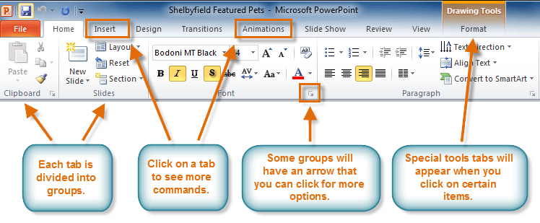

- Take a moment to view the PowerPoint Window become familiar with the buttons shown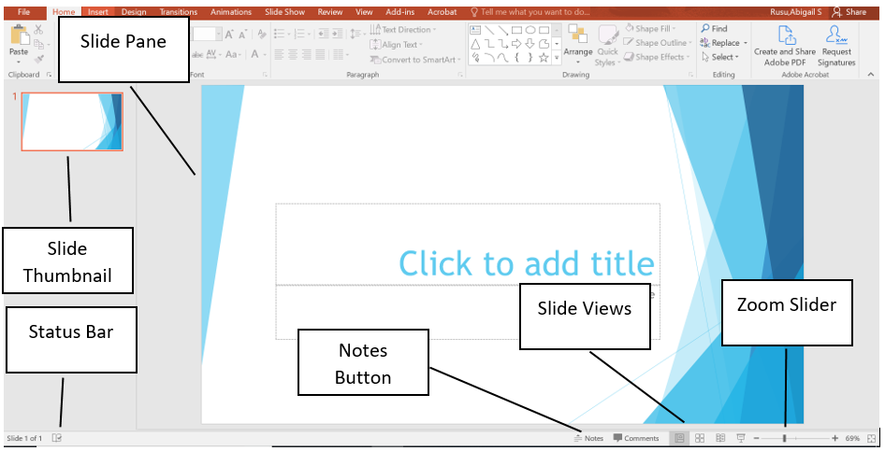

- Notice that the layout of Slide 1 includes a Title and a Subtitle placeholder
  - This is a common layout for the Title Slide.
  - All text, graphics, videos, or anything that is on a slide must be in a placeholder.

Step 3: Adding Text to a Slide
- Open the PP_Practice 1_Copy text file
- In the Click to add title placeholder, copy and paste Welcome New Students!
- In the Click to add subtitle placeholder, copy and paste Fall Orientation

Step 4: Adding Slides and Changing Slide Layout
- Home tab > Slides group > click the ▼ near New Slide > select Title and Content
- In the Click to add title placeholder, copy and paste Student Life
- With Slide 2 still active, Home tab> Slides group > click the ▼ near Layout > select Two Content.
  - Notice how the layout of Slide 2 changed.
- In the left content placeholder, copy and paste the following
Get involved with Student Life and Leadership!
Connect with fellow students
Discover empowerment
Make a difference
Step 5: Format All Items in a Placeholder
- Click the border around the left content placeholder to select the placeholder
  - Notice is changed from a dotted border to a solid border
- Home tab > Paragraphs group > click the ▼ near Bullets icon > select the Checkmark bullets
- Home tab> Font group > change the font size to 28


Step 6: Adding an Image from Stock Images
- In the right placeholder, click the insert stock images shortcut > select Stock Images
  - NOTE: If you do not have the insert stock image icon, do the following:
    - Insert tab > Images group > click the ▼ near Pictures > select Stock Images
- Search for College Students.
  - Choose any picture of college students and click insert to insert it into the placeholder.
Step 7: Adding Speaker Notes
- With Slide 2 displayed, in the Status Bar at the bottom of the screen, click Notes.
  - Notice that the Notes Pane displays below the Slide Pane.
- In the Notes Pane, copy and paste the following
We sponsor numerous campus events and opportunities for you to participate in our dynamic learning environment. Through Student Life, students engage in educational relationships that inspire positive social change, contributing to a richer and more fulfilling college experience. Not only that, students build leadership and professional skills that carry on through life.

Step 9: Adding Shapes
- Home tab > Slides group > click the ▼ near New Slide > select Title and Content layout.
- In the Click to add title placeholder, copy and paste Athletics
- In the content placeholder, copy and paste the following
Soccer
Golf
Tennis
Cross Country
Track and Field
Baseball
Softball
- Click the border around the content placeholder to select the placeholder
  - Notice is changed from a dotted border to a solid border
- Home tab> Font group > change the font size to 28
- With Slide 3 still active, on the Insert tab > Illustration group > click the ▼ near Shapes
- Scroll to Stars and Banners section > select the Explosion: 8 points shape
- The cursor will change into a +
- To the right of the bulleted list, click and drag the shape onto the slide.
- Inside the shape, double click, then copy and paste Find us on Social Media @NBCC Athletics
Step 10: Editing a Shape
- Use the Rotate handle (above the shape) to slightly rotate to the left
- Move the shape in line with the bottom text.
  - Use the guides to align the image.
- With the shape still selected, Shape Format tab > Shape Styles group > click the ▼ near Quick Styles > select the Colored Fill-Blue, Accent 2 Theme Style

Step 11: Add an Image from Files
- Home tab > Slides group > click the ▼ near New Slide > select Picture with Caption layout.
- Click Insert Picture (Fill) icon > select From Device
- Navigate to your Office Fund folder > select PP_Practice1_Image > click Insert
- With the image selected, Picture Format tab > Size group > click the ▼ near Crop > select Fit

Step 12: Adding Text to Slide and Notes Pane
- Select the content placeholder below the image, copy and paste It is great to be in Graphic Design!
- Select the next content placeholder and copy and paste Welcome to NBCC!
- Click the border around the content placeholder to select the placeholder
  - Notice is changed from a dotted border to a solid border
- Home tab> Font group > change the font size to 36
- With Slide 4 still active, ensure the Notes Pane displays.
- In the notes section, copy and paste the following speaker notes: Explain the NBCC commitment and the support available to students.

Step 13: Adding Word Art
- Home tab > Slides group > click the ▼ near New Slide > select Blank layout.
- Insert tab > Text group > click the ▼ near WordArt > select Gradient Fill Green Accent Color 5; Reflection (If you cannot find this exact one, choose one with a Reflection)
- Replace the filler text with Any Questions? (copy and paste)
- Click the border around the content placeholder to select the placeholder
  - Notice is changed from a dotted border to a solid border
- Home tab> Font group > change the font size to 72
- Change the font size of the WordArt to 72.
- Shape Format tab > WordArt Styles group > click the ▼ near Text Fill > select Blue Accent 2

Step 14: Adding a Footer
- Display Slide 1.
- Insert tab > Text Group > click Header & Footer
- Slide tab > check the box next to Footer > copy and paste the following: Orientation 2026
- Notes and Handouts tab > check the box next to Data and Time > select Fixed > copy and paste the following: Last updated 2026-09-22
- Ensure the box next to Page Number is checked
- Click Apply to All

Step 15: Presentation Views and Print Preview
- View tab > Presentation Views group > notice Normal is selected. This is the most common view when creating your presentation. Explore the other views:
  - Outline View
  - Slide Sorter
  - Notes Pages
  - Reading View
- File tab > Print > to view the Print Options
  - Although PowerPoint slides are meant for presentations, there is the option to print slides for the presenter and participants.
- Click Full Page Slides > choose Notes Pages
  - Scroll through the slides and notice that Slide 2 and Slide 4 are displaying the Notes.
- Click Notes Pages > choose 6 Slides Horizontal.
  - Notice how the data and page number displays on the slide in Print Preview

Step 16: Final Check
- There should be 5 slides in your slide deck
- Compare your presentation flyer with the example provided by your instructor (Scroll down).
- Make any modifications needed.
- Save your document again.
- Upload your completed PowerPoint document to the correct assignment folder in Brightspace.

